Python Project

Traffic Signs Recognition

Before Going to Project, Firstly, Let’s First Know about what Traffic Signs Recognition is??

What is Traffic Signs Recognition??

There are several different types of traffic signs like speed limits, no entry, traffic signals, turn left or right, children crossing, no passing of heavy vehicles, etc. Traffic signs classification is the process of identifying which class a traffic sign belongs to.

About the Python Project

In this Python project example, we will build a deep neural network model that can classify traffic signs present in the image into different categories. With this model, we are able to read and understand traffic signs which are a very important task for all autonomous vehicles.

Prerequisites

This project requires prior knowledge of Keras, Matplotlib, Scikit-learn, Pandas, PIL and image classification.

To install the necessary packages used for this Python data science project, enter the below command in your terminal:

pip install tensorflow keras sklearn matplotlib pandas pil

## Steps to Build the Python Project

To get started with the project, unzip the file…

You will find three files namely :

* gui.py
* traffic_classifier.h5
* traffic_sign.py

As Shown Below

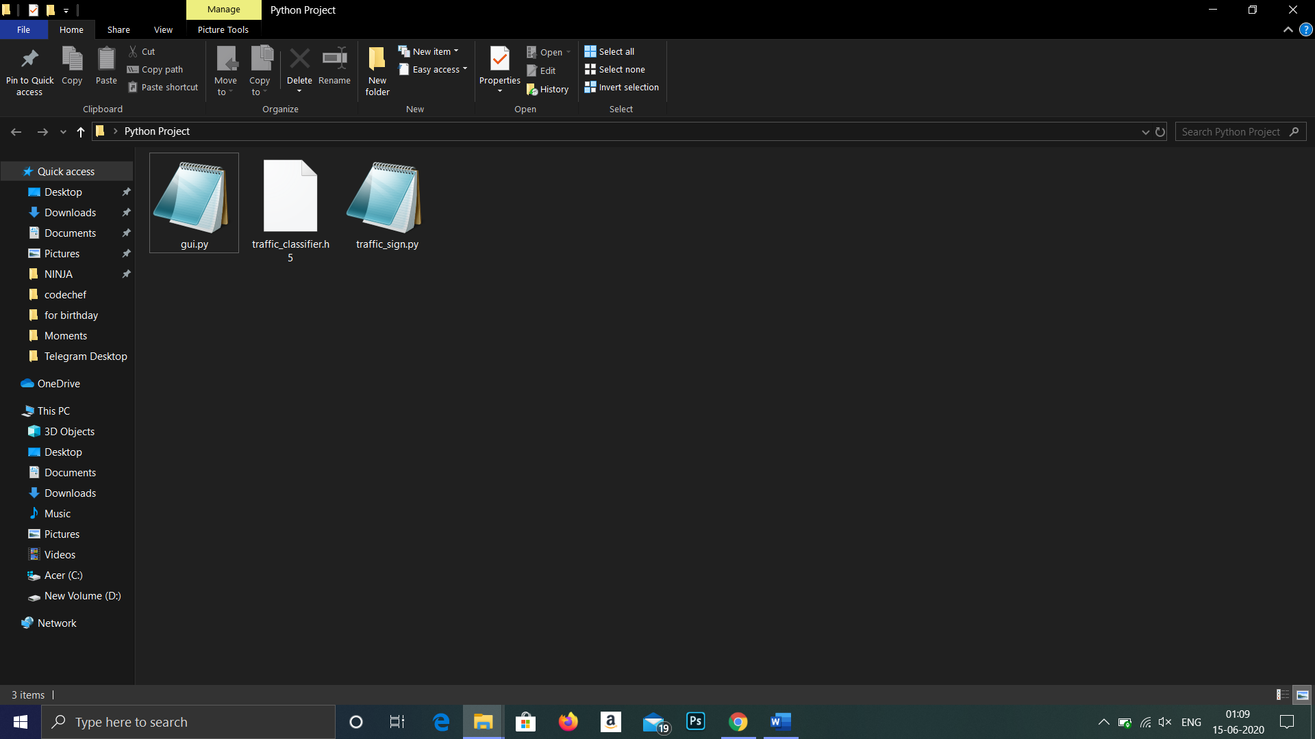

Things Required To Run This Project

* System should have a python compiler installed..
* Then,libraries like Keras, Matplotlib, Scikit-learn, Pandas, PIL should be installed and will need to be upto Date.
* Some Traffic signs which is to be tested with atleast of 320x320 px

Approach Taken To Make this Project

Our approach to building this traffic sign classification model is accomplished in four steps:

* Explore the dataset
* Build a CNN model
* Train and validate the model
* Test the model with test dataset

### Traffic Signs Classifier GUI

Now we are going to build a graphical user interface for our traffic signs classifier with Tkinter. Tkinter is a GUI toolkit in the standard python library. Make a new file in the project folder and copy the below code. Save it as gui.py and you can run the code by typing python gui.py in the command line.

In this file, we have first loaded the trained model ‘traffic_classifier.h5’ using Keras. And then we build the GUI for uploading the image and a button is used to classify which calls the classify() function. The classify() function is converting the image into the dimension of shape (1, 30, 30, 3). This is because to predict the traffic sign we have to provide the same dimension we have used when building the model. Then we predict the class, the model.predict_classes(image) returns us a number between (0-42) which represents the class it belongs to. We use the dictionary to get the information about the class. Here’s the code for the gui.py file.

## Summary

In this Python project with source code, we have successfully classified the traffic signs classifier with almost 95% accuracy and also visualized how our accuracy and loss changes with time, which is pretty good from a simple CNN model.